Linguistic Changes in Foreign Policy Political Discourse

Kayla Jordan

Missouri State University

Linguistic Changes in Foreign Policy Political Discourse

The foreign policy of any nation has far-reaching consequences both domestically and abroad. Foreign policy encompasses the choices a nation makes in relation to entities outside the nation (Kaufman, 2010). Numerous studies have sought to elucidate the role of the executive (Crichlow, 2005; Dyson, 2008; Dyson & Preston, 2006) in creating policy and the attitudes of the public toward those policies (Cohrs & Moschner, 2002; McCleary, Nalls, & Williams, 2009; Sahar, 2010). Few studies, however, have examined the role of the legislature in shaping foreign policy. This dearth is unfortunate, as the U.S. Congress has the power to declare war, limit the military engagement, and to control defense spending (Phelps & Boylan, 2002). Congress also reflects public opinion. Ansolabehere and Jones (2010) found that, generally, citizens have accurate perceptions of how their congressmen and women are voting and that approval of congressmen and women is influenced by how well their voting aligns with their constituencies’ preferences. Hence, the focus of this study will be on the U.S. Congress due to its importance in shaping policy.

As it is difficult to conduct typical studies with politicians, the language they produce is often used to draw conclusions about their attitudes and behaviors in research. One problem with many of these studies is size of their sample. Due to the time-consuming nature of linguistic studies, small groups of texts, such as all the statements by one president or one year of congressional speeches, are typically used; thus, restricting the conclusions which can be drawn to one person or time period. Automatic content analysis, such a tabulation of word frequencies, allows for much larger samples of language to be analyzed. However, studies that use this procedure often examine a limited set of topics or policies that politicians address. To expand the literature, the current study will use a type of word analysis to explore more complex constructs, such as honesty and aggression in language. In this study, I seek to use word frequency analysis to understand U.S. congressmen and women’s positions and attitudes toward U. S. foreign policy with Iraq, Iran, and North Korea.

**Language**

Language is at the heart of politics. Politicians release daily press statements to their constituencies, give speeches on the floor of Congress, and engage in debate with others at committee hearings. All discourse is composed of two types of words: content and function. Content words reflect the substance of the discourse; these words convey ideas. Function words reflect the style of the discourse; these words reflect how the ideas are being conveyed. Categories of function words include pronouns and prepositions, whereas categories of content words can include concepts (nouns, adjectives) such as *money* and *death* (Pennebaker, 2011). The Linguistic Inquiry and Word Count software (LIWC; Pennebaker, Chung, Ireland, Gonzales, & Booth, 2007) was developed to analyze language for these types words by computing word frequencies for words in 82 language categories. See Table 1 for categories and examples. Y. R. Tausczik and Pennebaker (2009) provided a review of more than 100 articles which established the link between language and psychological constructs such as honesty, group cohesion, and social status. These reviewed studies found pronouns and verb tense to be indicative of attentional focus. The use of first person pronouns indicated a self-focus and the use of third person pronouns indicated an others-focus, while verb tense indicates temporal orientation. Furthermore, plural third person pronouns were found to indicate greater social status and group cohesion. Language can also fluctuate in response to major events. Y. Tausczik, Faasse, Pennebaker, and Petrie (2012) found an increase in the use of death, health, and anxiety words in blogs and new outlets following a swine flu outbreak, as well as a decrease in positive emotion words. Fernandez, Paez, and Pennebaker (2009) found an increase in the use of first person pronouns in writing responses from an American sample following 9-11, and an increase in the use of social words, third person pronouns, and cognitive processes in a Spanish sample following the terrorist attacks in 2004.

These and other studies established how word frequencies could be used to explain psychological constructs in language. Pennebaker and King (1999) conducted several studies to establish the reliability and validity of the LIWC and to explore how language is related to larger psychological constructs. Using language samples from three different sources (psychiatric patients, college students, and psychological researchers), they found the overall reliability of the 82 categories to be .59. In a separate experiment, they discovered analyzed the most reliable categories with a factor analysis revealing four psychological constructs: Immediacy, Making Distinctions, The Social Past, and Rationalization. Whereas language categories give information about the frequency of word use, these constructs indicate different language styles reflecting underlying psychological processes. See Table 2 for formulas used to derive these factors. Pennebaker and King (1999) followed up on these initial studies to determine how these language factors related to motivation, personality, and demographic variables. They found that Immediacy positively correlated with classroom participation, neuroticism, and agreeableness and negatively correlated with need for achievement, openness to experience, SAT verbal scores, and need for cognition. Making Distinctions was found to be positively correlated with classroom participation and negatively correlated with need for affiliation, extraversion, conscientiousness, and positive affect.

In a study of blogs following 9-11, Cohn, Mehl, and Pennebaker (2004) utilized similar constructs using the word categories of the LIWC. Cognitive processing is reflected in the use of words such as *think* and *because* and indicates the level to which the writer or speaker seeks to understand and organize their thoughts. This concept is similar to the language factor, Rationalization, found in Pennebaker and King (1999) except cognitive processing does not account for emotion. Psychological distancing is a measure of the difference of the use of articles and longer words and the use of first-person singular pronouns, discrepancy words such as *would* and *could*, and present tense verbs. High levels of psychological distancing indicate an abstract and rational thought process whereas low levels of psychological distancing indicate a personal and experience-based thought process. Psychological distancing is the opposite of the Immediacy factor found by Pennebaker and King (1999). Cohn et al. (2004) examined more than 1,000 blogs from an online journal site over a period of time which spanned several months before and after 9-11 and found that cognitive processing and psychological distancing increased in the two weeks following 9-11. After those two weeks, cognitive processing declined below baseline levels, and psychological distancing persisted for the entire six weeks of the study. Furthermore, they found that even blogs, which did not focus on the events of 9-11, still demonstrated these language changes to a lesser extent.

Newman, Pennebaker, Berry, and Richards (2003) explored the possibility of using word frequencies to predict deception. Participants were requested to both tell the truth and lie concerning their attitudes on abortion, their friends, or the involvement in a mock crime. Deception was predicted by an increase in the use of negative emotion and motion words and a decrease in the use of first person singular pronouns, third person pronouns, and exclusive words. Word frequency was able to predict deception better than other participants and better than chance. Bond and Lee (2005) then used the results of the Newman et al. (2003) study to classify the truthfulness of prisoners’ statements. Participants were placed into dyads with one participant providing a mix of true and false statements and the other participant judging the veracity of the first participant’s statements. Bond and Lee found that the Newman et al. formula for deception classified 70% of statements correctly.

Pennebaker (2011) studied the language of terrorist groups to determine if language could predict aggression. Nearly 300 language samples were gathered from four Arabic extremist groups, two of which had committed violent terrorist attacks. In addition to the categories of the LIWC, Pennebaker also examined honesty, status, categorical thinking, and complex thinking. See Table 3 for the computational formulas of these constructs. Honesty represents the extent to which language used conveys truthfulness or deception. Status represents how the speaker or writer sees themselves in the social hierarchy of which they are a part. Categorical thinking represents a distant and static style of speaking or writing compared to a more fluid or dynamic style. Complex thinking indicated an intellectual or elaborate way of speaking or writing and represents the Making Distinctions factor found by Pennebaker and King (1999). Pennebaker (2011) found that the violent terrorist groups had less honest language, as well as less categorical thinking and less cognitive complexity. Overall, the language differences between violent and nonviolent terrorist groups suggested violent groups were more personal and charismatic whereas nonviolent groups were more intellectual. Pennebaker also found that violent terrorist groups used more simple words, more pronouns, more emotional words, and more inclusive words. One month prior to a terrorist attack, these groups used more personal pronouns, prepositions, conjunctions, and inclusive words while using fewer insight words, causation words, discrepancy words, tentative words, and exclusive words.

**Politics and Foreign Policy**

As the purpose of this study is to explore changes in political discourse, it is important to discuss how changes in the political environment can impact the behavior of politicians, which includes their language. The research in this area generally focuses on executives (presidents and prime ministers) and foreign ministers. Leudar, Marsland, and Nekvapil (2004) studied the language of George Bush, Tony Blair, and Osama bin Laden following 9-11. They found that all three individuals used language to establish an *us* versus *them* dichotomy to rationalize past events and orient future actions. Bush and Blair identified *us* versus *them* distinctions based on social, moral, and political grounds, whereas bin Laden made these distinctions using religious grounds. Dyson (2008) examined British prime ministers parliamentary responses to foreign policy questions from 1945-2008 for cognitive complexity markers within their language use. Words which indicated high cognitive complexity include *apparently*, *approximately*, and *otherwise*; low cognitive complexity words included *absolute*, *all*, and *overwhelming.* Dyson found differences between prime ministers and differences in variation such that some prime ministers were consistent in their complexity while other prime ministers seem to vary their cognitive complexity over time.

Dyson and Preston (2006) conducted a similar study to examine how the cognitive complexity of four U.S. presidents (Truman through Johnson) related to their use of historical analogy in the foreign policy statements. High complexity presidents (Eisenhower and Kennedy) were more likely to use sophisticated historical analogies and cross-cultural analogies than low complexity presidents (Truman and Johnson). Crichlow (2005) studied the policy preferences of U.S. foreign ministers for specific policy decisions. He found that conflict-oriented policy preferences were correlated with ministers’ distrust and belief in events ruled by chance while cooperative-oriented policy preferences were correlated with belief that others will be cooperative, belief in the stability of the future, and greater perception of control. With the exception of the belief that others will be cooperative, these relationships remain significant even when controlling for the level of provocation. To demonstrate the importance of ministers’ policy preferences, Crichlow found that the ministers’ policy preference was positively correlated with the official policy. Together, these studies demonstrate personal characteristics of executives, including their language use, can illuminate foreign policy preferences.

In addition to politician influence, public attitudes of foreign policy are an important area of investigation. Friese, Fishman, Beatson, Sauerwein, and Rip (2009) portrayed that the relationship between political orientation and support for the Iraq War was mediated by the participant’s attribution of responsibility for the war. Participants who were led to believe that the U.S. lied about Iraq’s possession of WMDs were less likely to support the war than those lead to believe that Iraq did posses WMDs. Sahar (2010) studied attributions of responsibility for the war in Afghanistan and the Iraq War denoting three major types of attributions: U.S. foreign policy in the Middle East, resentment of American successes, and terrorist personal traits. She then examined how these attributions related to patriotism, perceived threat, and support for war. In a 2001 sample, blind patriotism, which represents loyalty to one’s nation regardless of other factors, was positively correlated with the resentment attribution, perceived threat, support for the war in Afghanistan, and belief in the success of the War on Terror, and negatively correlated with the U.S. foreign policy attribution. Constructive patriotism positively correlated with all three attributions and perceived threat. In a 2005 sample, the correlations with blind patriotism remained the same except that the resentment attribution no longer correlated with blind patriotism. Constructive patriotism positively correlated with the U.S. foreign policy and terrorist traits attributes and negatively correlated with support for the Iraq War. Over time, blind patriotism, perceived threat, support for the war in Afghanistan, belief in success decreased while attributions of U.S. responsibility for the wars increased.

Cohrs and Moschner (2002) studied German students’ attitudes toward the Kosovo War and found that general attitudes toward war, which consisted of diffuse political support (conceptually similar to blind patriotism), militarism, and authoritarianism, positively correlated with support for the war in Kosovo. They also found evidence of a confirmation bias, such that those who were against the war selectively sought out information which reinforced those attitudes. McCleary et al. (2009) conducted a similar study of American college students’ attitudes toward the Iraq War, and discovered that blind patriotism strongly predicted support for the war while militarism and concern for national security predicted support to a lesser extent. Constructive patriotism and concern for civil liberties predicted opposition to the war.

Though the research on legislatures is much less extensive, a couple studies have looked at factors involved in legislatures’ foreign policy preferences, primarily the U.S. Congress. Kriner and Shen (2014) studied political discourse and voting in the U.S. House of Representatives pertaining to the Iraq War. They found that, for Democrats, antiwar rhetoric positively correlated with the number of war casualties from their districts. Furthermore, as the number of casualties from their district increased, Democrats were more likely to vote against war measures. Grimmer (2009) examined the press releases from U.S. Senators in 2007 to demonstrate how language could illuminate their political priorities. He found that committee leaders tend to focus on topics related to their committees, that senators focus on topics important to their home districts, and that senators from the same state have more similar priorities than senators from different states. While these two studies how language of legislative bodies can be examined, neither of these studies has examined linguistic styles in the legislature, which will be the focus of the current study.

Studying political language can be useful in predicting policy position and voting amongst politicians demonstrated by the following studies. Laver, Benoit, and Garry (2003) studied political discourse from the British, Irish, and German parliaments. Using reference texts that provided clear examples of different policy positions, they were able to predict policy positions of other political texts. For example, they found that politicians favoring less central control of education and health care used the word *choice* more often, while politicians favoring more central control referenced the *benefits* of central planning. Slapin and Proksch (2008) conducted a similar study which incorporated changes in positions over time using a liberal-conservative continuum. Using German political party manifestos over a span of 15 years, they found that their estimates of policy positions correlated highly with other methods of estimated policy positions such as hand-coding methods and expert surveys. Zirn and Stuckenschmidt (2014) used similar methods in a study of German politics to determine which members of a political coalition were assigned ministry positions. By comparing the linguistic similarity between each party’s manifesto and the coalition agreement, they were able to correctly classify 74% of the party assignment compared to 47% for a traditional hand-coding method. Together these studies demonstrate the usefulness of language to understand political policies. In a similar vein, the current study will focus on linguistic constructs to examine how real world events can influence policy preferences over time.

**History of U.S. Foreign Relations**

Iraq, Iran, and North Korea were named as the “axis of evil” by George W. Bush in 2002, and these countries are the target population for this study. These states have long been considered *rogue* states by the U.S and have been listed on the State Departments list of terrorist states. All of these nations have directly or indirectly engaged in terrorist attacks against Western states, and they have histories of pursuing nuclear weapon development as well as major human rights violations (Henriksen, 2012). Despite this, Caprioli and Trumbore (2005) found that Iraq is more likely to be the instigator of conflict , even though Iraq and North Korea are more likely than other states to be involved in conflict, and Iran is no more likely to be involved in conflict than other nations. Given this study, it will be crucial in the current study to examine how congressional language about each of these three nations may be different. In order to predict how foreign policy language has changed, it is important to understand the history of foreign relations with these nations. In addition, this history will also show some events that could have influenced congressional language at the time.

**Iraq.** Iraq became an independent nation in 1938 and initially had a good relationship with the U.S. When a military coup ousted the monarchy in 1958, Iraq leaned more toward the Soviet Union, which put it at odds with the U.S. However, as the Cold War drew to a close, Iraq provided a counterpoint to Iran, a greater perceived threat by the U.S. When Iraq went to war with Iran in 1980, the U.S. supported Iraq allowing them to buy military hardware from U.S. companies, providing them with intelligence information about Iran, and taking them off the list of terrorist states. U.S. relations with Iraq began to sour in 1990 when Saddam Hussein, the dictatorial leader of Iraq, began to vehemently speak against U.S. influence in the Middle East. Relations turned hostile later in that year with the Iraqi invasion of Kuwait. After diplomatic solutions failed, the U.S. plus a coalition of other nations took military action against Iraq in January 1991 and forced Iraqi troops to withdraw from Kuwait within two months. From then on, the U.S. took a harsher stance against Iraq, employing economic sanctions, nuclear weapons inspections, no-fly zones, covert operations to oust Hussein, and occasional overt operations such air strikes. While little changed in Iraq in the mid to late 1990s, foreign issues due to the conflict in Eastern Europe and domestic issues relating to oil imports softened the U.S. position toward Iraq. The terrorist attacks of 9-11 greatly impacted U.S. foreign policy toward the Middle East. War hawks in the White House, such as Dick Cheney and Donald Rumsfeld, pushed for action based on reports suggesting developments of weapons of mass destruction (WMDs) in Iraq. British intelligence confirming these reports, later found to be incorrect, was a major impetus for the U.S. invasion of Iraq in March 2003 (Henriksen, 2012).

Following the onset of military presence in Iraq, several important events in the war are worth noting. The first is that by May of 2003, President Bush announced the end of major combat operations in Iraq. However, in August 2003, insurgents bombed the United Nations headquarters in Baghdad killing 22 and prompting the withdrawal of several UN organizations (Bergen, 2011). In 2004, support for the war waned as the mistreatment of Iraqi prisoners became public knowledge and as doubt was raised about the veracity of the intelligence information about the Iraqi possession of WMDs – the major justification for the war ("U.S. Foreign policy timeline," 2008). In January 2005, a new Iraqi government was elected; however, the election was highly contested by the Iraqi Sunnis (Bergen, 2011). Then, in January 2007, President Bush authorized more military personnel to be sent to Iraq and in May of 2007, Congress approved an increase in funding for the war ("U.S. Foreign policy timeline," 2008).

**Iran.** As with Iraq, U.S. relations with Iran were not always hostile. During the World War I, Iran served as a peripheral battleground for the Turks, Russians, and British. Following WWI, the modern Iranian state was formed under military leader, Reza Khan, who inaugurated as the first shah of the Pahlavi dynasty. Reza Khan pushed for modernization in Iran, which angered many conservatives, as did his concessions to the British oil company, Anglo-Persian Oil, which controlled much of the oil in Iran. World War II saw further foreign intervention in Iran by the Soviet Union and Great Britain. Reza Khan was forced to abdicate, and the throne went to his son, Mohammad. The U.S. intervened to push the Soviet Union and Great Britain out of Iran and to assist in the development of the nation under the shah. Many in Iran grew to resent this intervention. Then, in 1951, Mohammad Mossadeq, became prime minister with a socialist-leaning parliament. The oil industry was nationalized which angered British and American interested causing both nations to boycott Iranian oil. The boycott in turn caused massive economic problems for Iran. Although the American intervention ended up played an insignificant role in proceeding events, the coup which led to the removal of Mossadeq, and the consolidation of the shah as absolute monarch cemented the animosity of many Iranians against the U.S. (Henriksen, 2012).

Resentment against the decadent shah and his Western allies grew, fulminating in the 1979 revolution bringing the religious leader, Ayatollah Khomeini, to power and turning Iran into a conservative anti-Western theocracy. Iranian hostility toward the U.S. was made clear in 1979 with the taking of the U.S. embassy in Tehran. American diplomatic and military actions failed to secure the 52 hostages taken from the embassy. A backdoor weapons deal orchestrated by the Reagan administration led to the release of the hostages over a year after the original attack. Relations with Iran continued to be hostile with the U.S. siding with Iraq in the Iran-Iraq War and U.S. military aid to Kuwait to protect them from Iranian attacks. Iran also supported numerous terrorist attacks against American targets in Lebanon in the 1980s. Relations remained relatively static through the 1990s. Following 9-11, Iran cooperated with U.S. intervention against the Taliban in Afghanistan for a short time. Soon after, Iran was once again funding various terrorist organization s throughout the Middle East designed to both conduct anti-Western activities and to support Shiite organizations in the more liberal Middle Eastern states (Henriksen, 2012).

The Iranian quest to develop long-range missiles and nuclear weapons cemented its hostile relationship with the U.S. In 2002, international nuclear inspections found Iran to be in violation of international nuclear agreements. Iran refused to back down from its uranium enrichment program, which stalled any negotiated with the West. Iran finally suspended its nuclear activities in 2004. The nuclear program was quickly restarted however in 2006 by newly elected president, Mahmoud Ahmadinejad. New sanctions against Iran were implemented in 2007. In response to President Obama’s requests to reopen diplomatic talks, Iran test fired a long-range missile. Civil unrest broke out in Iran in 2009 that quelled within the year, during which the U.S. remained neutral. In 2010, U.S. adopted stricter sanctions against Iran blacklisting many Iranian banks for funding nuclear weapon development. The numerous protests of the Arab Spring in 2011 prompted further U.S. concern in the Middle East the possibility of Iranian influence expanding in the region materialized. Continued Iranian efforts to develop nuclear weapons keep the U.S. wary of the theocratic nation (Henriksen, 2012).

**North Korea.** The final nation of the *axis of evil* is the totalitarian, communist regime of North Korea. Following WWII, the Korean peninsula was freed from Japanese rule. The Soviet Union became the primary influence in what would become North Korea, and the U.S. exerted influence in the soon-to-be South Korea. This separation cemented itself when, in 1950, the leader of North Korea, Kim Il Sung, invaded South Korea beginning a three year proxy conflict, which has never technically ended. Even after an armistice was signed, North Korea continued to provoke both South Korea and the U.S. with acts such as seizing an American ship in 1968. North Korea cemented itself as a rogue state with its development and quest for nuclear capabilities. The Soviet Union restrained North Korea, but with the fall of the Soviet Union, North Korea was free to freely pursue its nuclear agenda. Mobilization of the North Korean army and evidence of nuclear advances forced the U.S. to respond. Not wanting to spark another war on the peninsula, the U.S. attempted to negotiate with North Korea trying to tempt them with light-water reactors, which would provide energy without allowing nuclear weapon materials. In 1994, under the new North Korean leader, Kim Jong Il, an agreement was reached to halt North Korea’s nuclear quest. Relations stabilized for a time, but heated up again in 1998 when North Korea test-fired a long range missile and seemed to be violating the nuclear arms agreement (Henriksen, 2012).

U.S. attention was quickly diverted to Afghanistan and Iraq following 9-11, however, evidence of North Korea’s steadily developing nuclear program kept relations tense. In 2005, after two years of negotiations with the Six-Party Talks, an agreement was finally reached with North Korea whereby they agreed to abandon their nuclear quest and readmit UN inspectors in return for foreign aid. Unfortunately, the agreement coincided with the discovery by the U.S. Treasury that North Korea had been counterfeiting U.S. currency prompting the U.S. to blacklist the bank through which North Korea had been laundering money. North Korea retaliated in 2006 by firing several missiles and carrying out a nuclear test violating their new agreement. In 2007, a new agreement was reached which included a new provision that the U.S. would remove North Korea from the list of state sponsors of terrorism. The agreement came to naught however, as North Korea refused to hold up its end even after the U.S. released North Korean assets frozen in the blacklisted bank. In 2008, the U.S. discovered that North Korea had aided Syria in developing its own nuclear program. Further negotiations were attempted, but by the time President Bush left office in 2009, little progress had been made (Henriksen, 2012).

Under President Obama, policy toward North Korea remained mostly the same, but North Korean actions spurred the U.S. to action. Violating previous agreements, North Korea launched another missile with crashed into the Pacific in April 2009. In response, the U.S. went to the U.N. to enforce harsher sanctions, albeit they only partially supported by the U.N. North Korea responded by ousting nuclear inspectors and testing a nuclear device. The interplay between the U.S. and North Korea has continued in with sanctions and retaliations throughout the years. Late 2011, Kim Jong-Un became the new leader of North Korea who despite agreeing in 2012 to suspend nuclear testing announced plans to launch a satellite (Henriksen, 2012).

**Purpose and Hypotheses**

The purpose of this study is to examine linguistic changes in the foreign policy discourse in Congress pertaining to U.S. relations with Iraq, North Korea, and Iran. Specifically, I will explore changes in language reflecting metalinguistic constructs in response to major events in foreign relations such as missile launches and major human rights violations.

*Hypothesis 1*: Complex thinking, cognitive processing, and psychological distancing will increase following acts of aggression perpetrated by Iraq, Iran, and North Korea.

*Hypothesis 2:* Categorical thinking, honesty, and status will change in response to acts of aggression as a function of party affiliation.

**Method**

**Data Collection**

Data were collected using the Congressional Record, which is an online archive of speeches on the floor of both chambers of Congress available through U.S. Government Printing Office. The archive is organized by year, month, day, and chamber of Congress. For each day and chamber, a file exists for each debate/speech for that day. Each file could have one or multiple speakers. Files with multiple speakers are typically debates on specific legislation, such as the Authorization for the Use of Military Force in Iraq. Each file is given a title that specifies the subject of the speech/debate. These titles were scanned for the keywords *Iraq, Iran,* and *North Korea.* These files were downloaded as pdfs or text files.

**Sample**

**Senate.**  A total of 1024 Senate speeches were collected from the Congressional Record available online through the U.S. Government Publishing Office. Of these speeches, 943 speeches pertained to relations with Iraq, 57 pertained to Iran, and 24 pertained to North Korea. Speeches were made by 143 senators over the years 1998 – 2013. The average word count for the speeches was 1393.93 (*SD* = 1050.99). Democrats made 522 of the speeches, and Republicans delivered 468 of the speeches. The average time in office was 17.67 years (*SD* = 10.88).

**House of Representatives.** From the House of Representatives, 3512 speeches were gathered from the Congressional Record. Of these, 3315 speeches were about Iraq, 172 about Iran, and 25 about North Korea. Speeches were made by 570 congressmen and women between 1998 – 2013. The average word count was 745.64 (*SD* = 946.08). Democrats gave 2100 speeches, and Republicans gave 1412. The average time in office was 10.67 years (*SD* = 8.32).

**Foreign Affairs Committees.** Additionally, 254 speeches were collected from the hearings of the Senate and House Foreign Affairs Committees. Of these, 24 pertained to Iraq, 134 to Iran, and 96 to North Korea. Speeches were made by 94 members of Congress from 1998 to 2013. The average word count was 1111.30 (*SD* = 1591.95). Democrats made 144 speeches, and Republicans made 110 speeches. The average time in office was 12.82 years (*SD* = 9.10). For all venues, multiple speakers/speeches were given on the same day, and for analyses, this meant several speeches contributed for to the average for that time point.

**Data Processing**

Speech files were then processed to create a readable LIWC format, and each file only contained one speaker, day, and region combination. Cleaned files included no labels or long quotes, and obvious spelling errors were corrected. Word frequency analysis was then conducted for each file using the LIWC. Further information about each speaker was collected and added to the dataset. This information included each speaker’s party affiliation, the years they have been in Congress, and the state they represented.

**Metalinguistic Constructs.** From the categories included in the LIWC analysis, metalinguistic constructs were calculated: honesty, status, complex thinking, categorical thinking, cognitive processing, and psychological distancing. See Table 2 for formulas for these constructs. These constructs are computed by first calculating the *z* (standardized) scores of the each separate word category, then calculating the formulas provided in Table 1. Therefore, the values for the overall constructs can be interpreted as *z* scores, which sets a construct score of 0 to the average level of that construct across the sample. Construct scores from -2 to 2 represent an average range of scores that 95% of the speeches would typically fall into. Construct scores less than -2 or greater than 2 represent speeches significantly lower or higher than average.

**Results**

**Data Analytic Plan**

***Function estimation.*** The proposed hypotheses focused on changes in language over a 15-year span of time. As shown in the attached figures, the trend of linguistic constructs was not linear during this time period. Therefore, nonparametric regression with smoothing splines was used to define the function by estimating the regression line at each point around a given interval. The width of this interval, referred to as the smoothing parameter or *h*, can be estimated either subjectively, by choosing a value resulting in a smooth curve, or objectively, by using automatic methods such as cross-validation ([Bowman, 2006](#_ENREF_4" \o "Bowman, 2006 #798); [Faraway, 2006](#_ENREF_12" \o "Faraway, 2006 #797)). The current analyses were conducted using the *sm* package in R ([Bowman & Azzalini, 2014](#_ENREF_5" \o "Bowman, 2014 #799)). Regression analyses were carried out using the *sm.regression* function and the smoothing parameters were estimated using *hcv* cross-validation function.

***Hypothesis Analysis.*** Using the regression line, estimated linguistic construct scores were analyzed to determine when significant changes in speech patterns occurred. Constructs are *z*-scored, and therefore, the differences between time points or parties were compared a *zdifference*of 2.71 (Bonferroni corrected α = .003 for 15 analyses). Initially, separate models were conducted for Iraq, Iran, and North Korea for each construct. However, due to sample sizes, speeches pertaining to Iran and North Korea combined for one model per construct.

**Hypothesis 1**

**Complex Thinking.** Figure 1 contains the overall regression line for changes in complex thinking over time in discourse pertaining to U.S. foreign policy toward Iraq with separate lines for Democrats and Republicans. As indicated in Table 3, the first wave of changes in categorical thinking was found from March 2000 through October 2001. These changes were not significantly different during March and September, but as shown in Figure 1, Republicans and Democrats diverged dramatically in April 2001 (*zdifference =* 3.83). This difference persisted through October 2001 (3.75) indicated that Democrats were using significantly more complex thinking during this time period. One limitation to these analyses is smaller speech numbers during these time periods.

In March 2010, overall level of complex thinking was -1.39 with little difference between parties (-1.72). In February 2011, overall complex thinking had increased to 1.65, and the difference between Democrats and Republicans was 2.86 with Democrats demonstrating more complex thinking. In January 2012, overall complex thinking decreased to -2.03 with moderate differences between Democrats and Republicans (2.26) with Republicans displaying more complex thinking. In April 2013, the overall level had not changed much; however, major differences between parties emerged (4.17) with Democrats displaying more complex thinking. By August 2013, the overall level remained relatively unchanged and the differences between parties decreased severely (0.44).

Figure 2 contains regression line for changes in complex thinking in speeches about Iran and North Korea. In August 2000, the overall level of complex thinking was 0.81 with little difference between parties (1.31). By April 2001, the overall level changed little (0.45) and parties differences remained small (-1.72). In December 2001, overall complex thinking remained the same (0.66); however, Democrats displayed significantly greater complex thinking than Republicans (3.99). By June 2002, overall complex thinking rose (2.37), and the party differences grew even wider (6.16). By March 2003, complex thinking decreased (0.15), and party differences decreased as well (2.12). By September 2004, complex thinking decreased further (-1.06), and party differences remained roughly the same (3.23). From 2010 to 2013, party differences were nonexistent; however, the overall level of complex thinking decreased from 1.21 in July 2010 to -3.29 in July 2013.

**Cognitive Processing.** Figure 3 displays the changes in cognitive processing in the congressional discourse pertaining to Iraq. In July 1998, the overall level of cognitive processing was .60; the difference between Democrats and Republicans was 4.28 with Democrat displaying more cognitive processing. By October 1999, overall cognitive processing remained the same (.50), and party differences declined dramatically (.24). In October 2001, cognitive processing had decreased slightly (-.83), while party differences increased slightly (2.26) with Democrats demonstrating less cognitive processing. By June 2002, cognitive processing increased slightly (.50), and party differences remained similar except Democrats used more cognitive processing. In November 2003, trends remained the same, yet cognitive processing by Democrats declined. From 2011 to 2013, cognitive processing varied greatly. In May 2012, overall cognitive processing was -.66, and parties differed by 2.40 with Democrats used less cognitive processing. By January 2013, party differences declined (.99) as did overall processing (-2.30).

Figure 4 shows changes in cognitive processing in congressional discourse about Iran and North Korea. Over the time under study, minor changes occur; however, the overall level of cognitive processing never varies more than one point away from the mean of 0. Likewise, party differences over time never exceed 2.20 points.

**Psychological Distancing.** Figure 5 displays changes in psychological distancing in discourse about Iraq. In March 1998, the overall level of psychological distancing was 1.33 with Democrat more distant than Republicans by 2.02. By May 2000, psychological distancing decreased dramatically (-7.84), and party differences increased with Democrats becoming less distant. Distancing increased (-3.68) by November 2000 while party differences decreased (1.70). Over the rest of the time studies, distancing remained unchanged and party differences were small to non-existent.

Figure 6 shows changes in discourse pertaining to Iran and North Korea. In September 1998, the overall level of psychological distancing was 2.04, and Democrats were more distant than Republicans (2.55). By August 1999, distancing decreased (-2.50) with Democrats becoming less distant (3.86). Distancing increased again by October 2000 and Democrats remained less distant (3.61). In July 2001, psychological distancing by Democrats increased dramatically (9.89). In February 2002, overall distancing decreased (-1.50), and party differences decreased however remained high (3.73) with Democrat being less distant. By October 2002, distancing further decreased (-3.56), and party differences increasing slightly (4.36) with Democrats remaining less distant. In June 2004, overall psychological distancing increased slightly (.61), and party differences increased (5.29) with Democrats becoming more distant and Republicans less distant. In March 2005, distancing declined (-2.37), and party differences decreased (-1.87). By November 2007, distancing increased (1.23), but party differences remained small (1.62). By July 2010, overall distancing remained roughly the same (-.76), however party differences increased (3.36) with Democrats displaying more distant language. In December 2010, overall distancing increased slightly (1.05), and party differences increased (5.72) with Republicans being more distant. While party differences decreased, overall distancing increased over the next two years reaching 3.72 in May 2013.

**Hypothesis 2**

**Categorical Thinking.** Figure 7 displays party differences in categorical thinking over time for foreign policy discourse about Iraq. Throughout the time period, party differences are relatively small. The largest party differences occur in March 2010 (2.48) with Democrats using more categorical thinking and in July 2013 (2.00) with Republicans using more categorical thinking.

Figure 8 shows party differences in categorical thinking for discourse about Iran and North Korea. The largest party differences occur in January 2004 (3.01) with Democrats using more categorical thinking and January 2011 (3.28) with Republicans using more categorical thinking.

**Honesty.** Figure 9 presents party differences in honesty for discourse about Iraq. Democrats demonstrated significantly more honest language from December 1999 to October 2000 with differences ranging from 2.86 to 4.28. Differences increased again to 2.62 in February 2010 with Democrats still showing more honest language.

Figure 10 presents party differences in discourse about Iran and North Korea. The largest difference (4.61) is found in May 2013 with Republicans displaying more honest language. For October 2002, there is a difference of 2.77 with more honest language from Democrats, and for September 2012, there is a difference of 2.63 with more honest language from Republicans.

**Status.** Figure 11 shows party differences in status in foreign policy discourse about Iraq. The largest differences were found in 2000 and 2001. In June 2000, the difference was 3.44 with Republican language showing higher status. In May 2001, the difference was 3.64 with Democratic language showing higher status.

Figure 12 presents party differences in status in discourse about Iran and North Korea. The largest difference occurred in June 2001 (15.44) with Republican language displaying much higher status than Democratic language. Large differences also occurred in February 2011 (2.84) with Republican language showing higher status and July 2013 (2.96) with Democratic language showing higher status.

**Discussion**

Results seem to indicate that instead of acts of aggression impacting congressional language, larger world events seem to have the most impact contrary to Hypothesis 1. For Iraq, changes were expected from 2002 to 2008 as those are when most acts of aggression by Iraq occurred as well as most major developments of American military operations took place. Instead, major fluctuations were seen in complex thinking and psychological distancing in 2000 and 2001. Specifically, in 2000, complex thinking increases while psychological distancing decreases. Then, those trends reverse in 2001 though complex thinking increases again in October 2001. Given the timing, these changes seem unrelated to any event in foreign affairs; however, these changes do seem to line up quite well with the 2000 U.S. presidential election. The changes in complex thinking later in 2001 are likely due to 9-11. Additionally, changes were also observed in complex thinking and cognitive processing from 2010-2013. These changes were likely indirectly influences by the Arab Spring which created concern for the entire Middle East region.

For Iran and North Korea, no changes were found for cognitive processing. For complex thinking, many changes occur in 2001-2002 which vary by party which were likely influenced by the presidential election and 9-11. Decreases in complex thinking occurred throughout 2010-2013 likely influenced by the Arab Spring. For psychological distancing, changes from 1999-2001 could be attributable the presidential election. Changes from late 2001-2002 attributed to 9-11. Changes from 2002-2004 could have been influenced by Iran’s violations of nuclear arms agreements. Finally increases in distancing from 2011-2013 were likely due to the Arab Spring.

As for Hypothesis 2, a few party differences in categorical thinking, honesty, and status emerged though not necessarily due to acts of aggression. For categorical thinking, the largest, and possibly only significant, party difference occurred in 2011 likely influenced by the Arab Spring and/or aggressive actions by North Korea toward South Korea. Republicans used more categorical thinking at this time indicating they may have viewed the situation in more black and white terms. For honesty, the largest party difference was found in 1999-2000 with Democrats using more honest language; it seems likely that this difference may have been more influenced by the domestic concerns of the upcoming presidential election than foreign policy problems. For status, the largest party difference occurred in 2001 with Republican language reflecting higher status; once again, given the context, this likely reflects concerns with the presidential election.

Three events are likely candidates to have impacted congressional foreign policy discourse: the 2000 election, 9-11, and the Arab Spring. Preceding the 2000 election, complex thinking increases which could be candidates working to foment a cogent policy towards Iraq where action may be necessary; psychological distancing decreases which would also make sense for candidates forming policies as they would be forced to engage with the issues. After the election, complex thinking decreases and psychological distancing increases. Following 9-11, complex thinking increases which could indicate members of Congress engaging and planning a response to the catastrophe. Psychological distancing decreased which could also be members of Congress forcing themselves to engage rather than withdraw. Following the Arab Spring, complex thinking decreased but only for discourse about Iran and North Korea; this could either a lack of engagement with the foreign policy issues with those nations or a simplification of those issues in the face of problems elsewhere in the region. Psychological distancing increased in discourse about Iran and North Korea suggesting disengagement with the foreign policy problems of those nations; this could make sense in the light of the potential for U.S. engagement elsewhere as the Arab Spring grew and became more complex.

Congressional language is highly variable, changing quickly and often. However, these changes do seem to have some connection to real world events, and these changes could help us to understand how decision makers are responding psychologically to these events.

Table 1

*LIWC Categories and Examples*

|  |  |  |  |
| --- | --- | --- | --- |
| Constructs | Examples | Constructs | Examples |
| **Pronouns** | | **Cognitive** **Mechanisms** | |
| First person singular | I, me, mine | Insight | think, know |
| First person plural | we, us, our | Causation | because, effect |
| Second person | you, your | Discrepancy | should, would |
| Third person singular | she, him | Tentative | maybe, perhaps |
| Third person plural | they, their | Certainty | always, never |
| **Verbs** | | Inhibition | block, stop |
| Past tense | went, had | Inclusive | with, include |
| Present tense | is, does | Exclusive | but, without |
| Future tense | will |  |  |
| **Other** | | **Personal Concerns** | |
| Adverbs | very, really, quickly | Achievement | hero, win |
| Articles | a, an, the | Money | cash, owe |
| Prepositions | to, with, above | Religion | church, mosque |
| Conjunctions | and, but, whereas | Death | bury, kill |
| Negations | no, not, never |  |  |
| Quantifiers | few, many, much |  |  |
| **Social-Emotional** | | **Relativity** | |
| Social processes | talk, they | Motion | arrive, go |
| Positive emotion | love, nice | Space | down, in |
| Negative emotion | hurt, hate | Time | end, until |

*Note*. These categories were selected from the larger LIWC output offerings as the most common categories used in research.

Table 2

*Metalinguistic Construct Formulas*

|  |  |  |
| --- | --- | --- |
| Construct | Formula | Reference |
| Honesty | I-words + words/sentence + big words + exclusives + conjunctions + insight + time + motion – discrepancies – social – you – impersonal pronouns – positive emotion | Newman, Pennebaker, Berry, & Richards (2003) |
| Status | we-words + you-words – I-words | Pennebaker (2011) |
| Categorical thinking | articles + prepositions + big words – verbs | Pennebaker (2011) |
| Complex thinking | exclusive + conjunctions + words/sentence + negations + insight + cause-inclusive | Pennebaker (2011) |
| Cognitive processing | insight + causation | Cohn, Mehl, and Pennebaker (2004) |
| Psychological distancing | articles + big words - I-words – discrepancy – present tense verbs | Cohn et al. (2004) |

*Note.* The formulas listed are based on the z scores of the LIWC categories percentage of the document.

|  |  |  |  |
| --- | --- | --- | --- |
| Country | Construct | 2000s | 2010s |
| Iraq | Complex Thinking | March 2000 (1.36)  September 2000 (4.61)  April 2001 (4.56)  October 2001 (-0.66) |  |
| Cognitive Processing |  |  |
| Psychological Distancing |  |  |
| Categorical Thinking |  |  |
| Honesty |  |  |
| Status |  |  |
| Iran/North Korea | Complex Thinking |  |  |
| Cognitive Processing |  |  |
| Psychological Distancing |  |  |
| Categorical Thinking |  |  |
| Honesty |  |  |
| Status |  |  |

*Note*. Overall *z*-scores for each time point are presented in parentheses.

*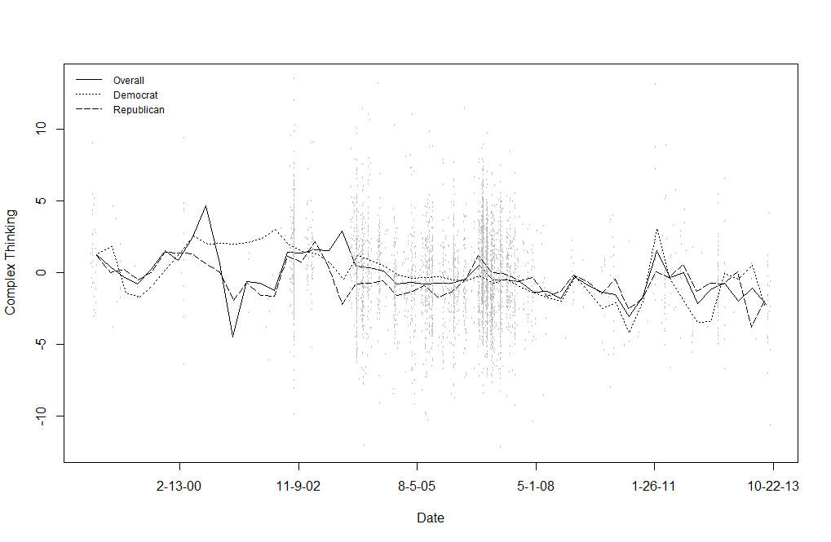Figure 1*. Changes in Complex Thinking in Congressional Speeches about U.S. Foreign Policy with Iraq

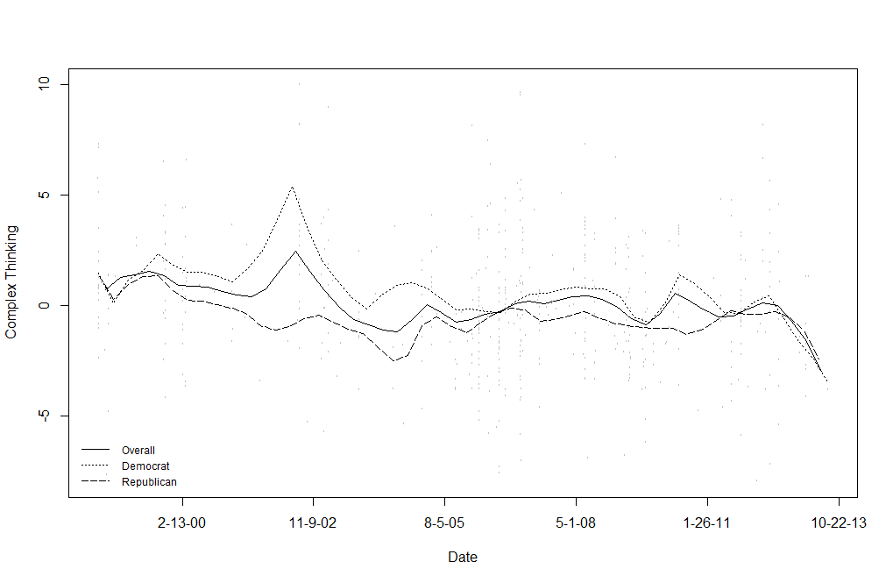*Figure 2*

Changes in Complex Thinking in Congressional Speeches about U.S. Foreign Policy with Iran and North Korea

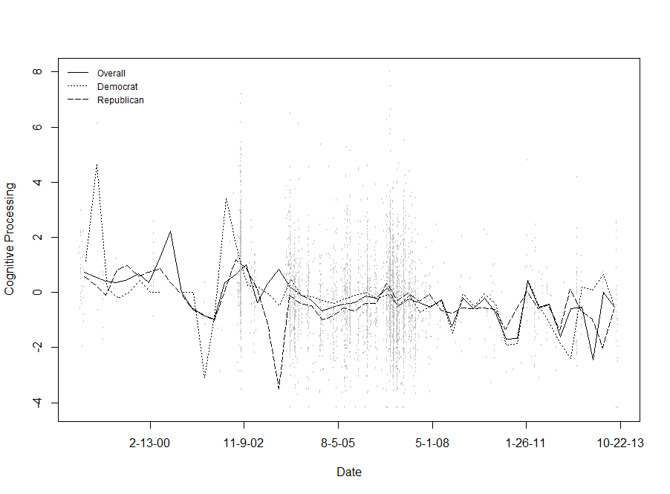

*Figure 3*

Changes in Cognitive Processing in Congressional Speeches about U.S. Foreign Policy with Iraq

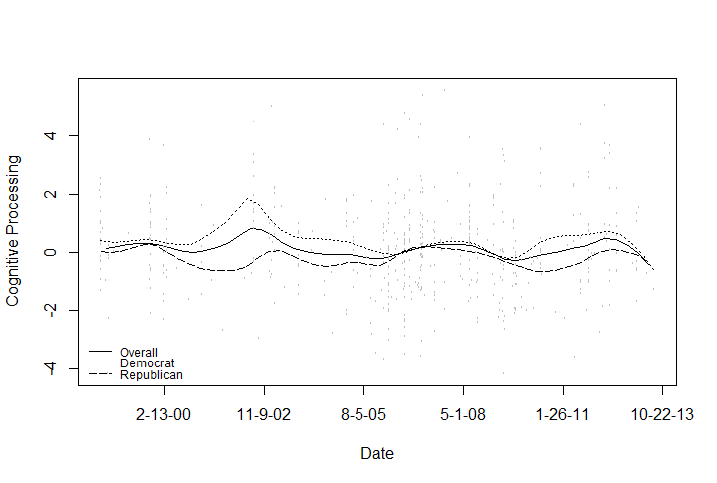

*Figure 4*

Changes in Cognitive Processing in Congressional Speeches about U.S. Foreign Policy with Iran and North Korea

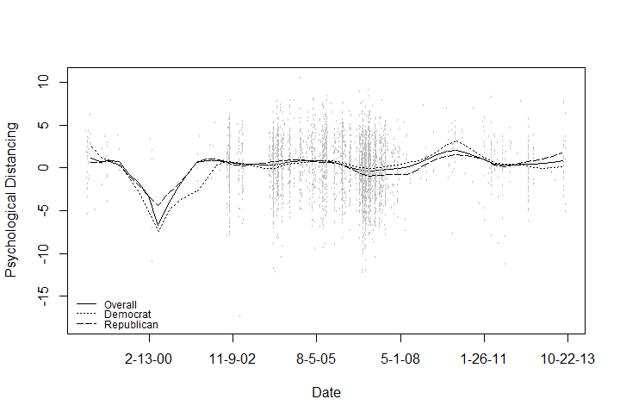 *Figure 5*

Changes in Psychological Distancing in Congressional Speeches about U.S. Foreign Policy with Iraq

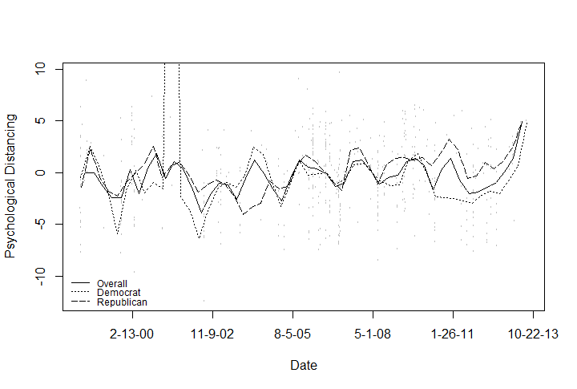

*Figure 6*

Changes in Psychological Distancing in Congressional Speeches about U.S. Foreign Policy with Iran and North Korea

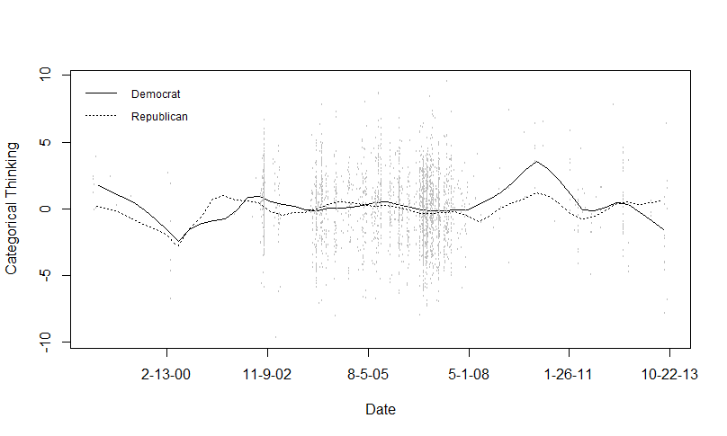

*Figure 7*

Party Differences in Categorical Thinking in Congressional Speeches about U.S. Foreign Policy with Iraq over Time

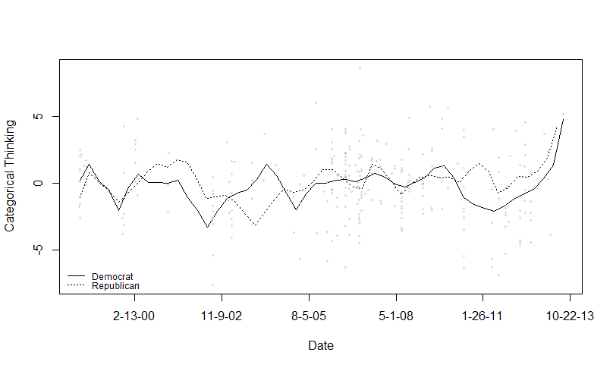

*Figure 8*

Party Differences in Categorical Thinking in Congressional Speeches about U.S. Foreign Policy with Iran and North Korea over Time

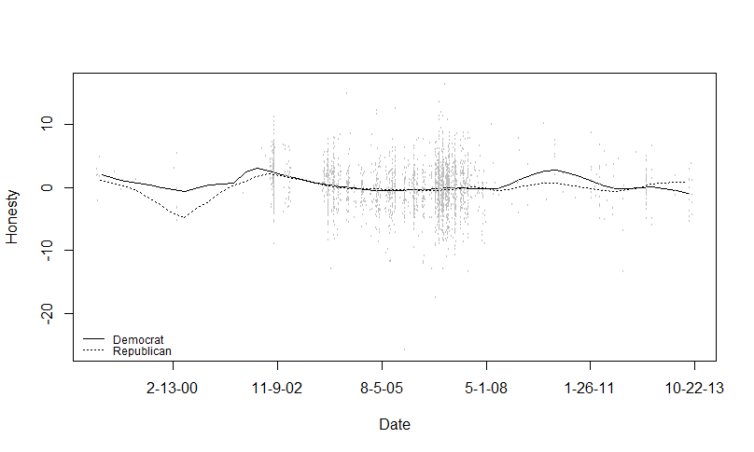

*Figure 9*

Party Differences in Honesty in Congressional Speeches about U.S. Foreign Policy with Iraq over Time

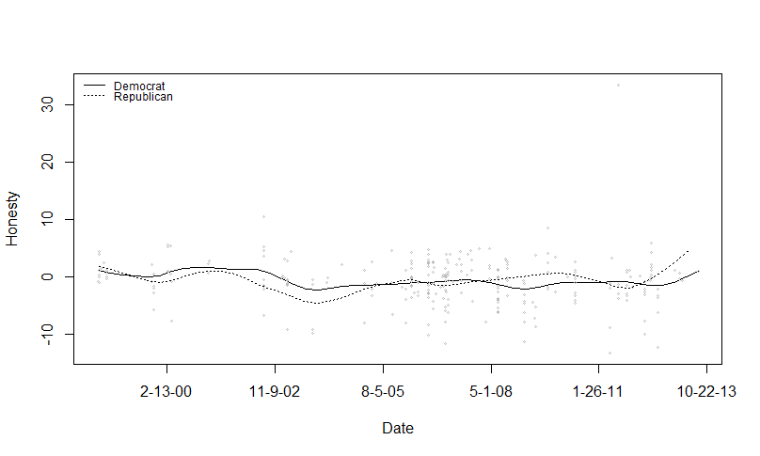

*Figure 10*

Party Differences in Honesty in Congressional Speeches about U.S. Foreign Policy with Iran and North Korea over Time

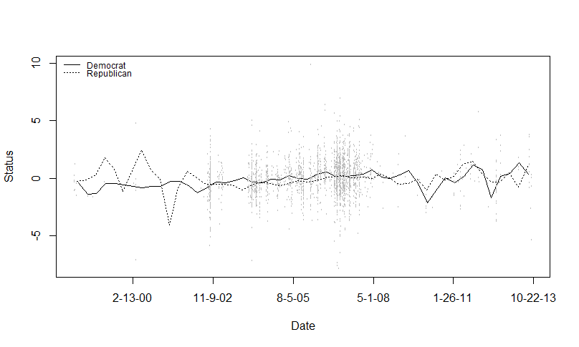

*Figure 11*

Party Differences in Status in Congressional Speeches about U.S. Foreign Policy with Iraq over Time

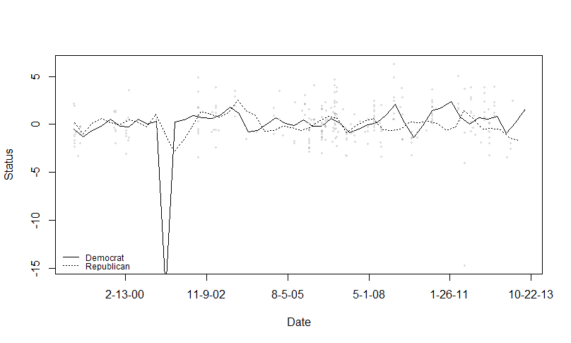 *Figure 12*

Party Differences in Status in Congressional Speeches about U.S. Foreign Policy with Iran and North Korea over Time

References

Ansolabehere, S., & Jones, P. E. (2010). Constituents’ responses to congressional roll-call voting. *American Journal of Political Science, 54*(3), 583-597. doi: 10.1111/j.1540-5907.2010.00448.x

Bergen, P. L. (2011). *The longest war: The enduring conflict between america and al-qaeda*. New York, NY: Free Press.

Bond, G. D., & Lee, A. Y. (2005). Language of lies in prison: Linguistic classification of prisoners' truthful and deceptive natural language. *Applied Cognitive Psychology, 19*(3), 313-329. doi: 10.1002/acp.1087

Bowman, A. W. (2006). Comparing nonparametric surfaces. *Statistical Modeling, 6*, 279-299.

Bowman, A. W., & Azzalini, A. (2014). Smoothing methods for nonparametric regression and density estimation (R version 2.2-5.4 ed.).

Caprioli, M., & Trumbore, P. F. (2005). Rhetoric versus reality: Rogue states in interstate conflict. *Journal of Conflict Resolution, 49*(5), 770-791. doi: 10.1177/0022002705279335

Cohn, M. A., Mehl, M. R., & Pennebaker, J. W. (2004). Linguistic markers of psychological change surrounding september 11, 2001. *Psychol Sci, 15*(10), 687-693. doi: 10.1111/j.0956-7976.2004.00741.x

Cohrs, J., & Moschner, B. (2002). Antiwar knowledge and generalized political attitudes as determinants of attitude toward the kosovo war. *Peace and Conflict: Journal of Peace Psychology, 8*(2), 139-155.

Crichlow, S. (2005). Psychological influences on the policy choices of secretaries of state and foreign ministers. *Cooperation and Conflict, 40*(2), 179-205. doi: 10.1177/0010836705047583

Dyson, S. (2008). Text annotation and the cognitive architecture of political leaders: British prime ministers from 1945–2008. *Journal of Information Technology & Politics, 5*(1), 7-18. doi: 10.1080/19331680802149624

Dyson, S., & Preston, T. (2006). Individual characteristics of political leaders and the use of analogy in foreign policy decision making. *Political Psychology, 27*(2), 265-288. doi: 10.1111/j.1467-9221.2006.00006.x

Faraway, J. J. (2006). *Extending the linear model with r: Generalized linear, mixed effects, and nonparametric regression models*. Boca Raton, FL: Taylor & Francis.

Fernandez, I., Paez, D., & Pennebaker, J. W. (2009). Comparison of expressive writing after the terrorist attacks of september 11th and march 11th. *International Journal of Clinical Health & Psychology, 9*(1), 89-103.

Friese, M., Fishman, S., Beatson, R., Sauerwein, K., & Rip, B. (2009). Whose fault is it anyway? Political orientation, attributions of responsibility, and support for the war in iraq. *Social Justice Research, 22*(2-3), 280-297. doi: 10.1007/s11211-009-0095-2

Grimmer, J. (2009). A bayesian hierarchical topic model for political texts: Measuring expressed agendas in senate press releases. *Political Analysis, 18*(1), 1-35. doi: 10.1093/pan/mpp034

Henriksen, T. H. (2012). *America and the rogue states*. New York, NY: Palgrave McMillan.

Kaufman, J. P. (2010). *A concise history of u.S. Foreign policy*. Lanham, MD: Rowman & Littlefield.

Kriner, D., & Shen, F. (2014). Responding to war on capitol hill: Battlefield casualties, congressional response, and public support for the war in iraq. *American Journal of Political Science, 58*(1), 157-174. doi: 10.1111/ajps.12055

Laver, M., Benoit, K., & Garry, J. (2003). Extracting policy positions from political texts using words as data. *The American Political Science Review, 97*(2), 311-331. doi: 10.1017/s0003055403000698

Leudar, I., Marsland, V., & Nekvapil, J. (2004). On membership categorization: ‘Us’, ‘them’ and‘doing violence’ in political discourse. *Discourse and Society, 15*(2), 243-266. doi: 10.1177/0957926504041019

McCleary, D. F., Nalls, M. L., & Williams, R. L. (2009). Antiwar knowledge and generalized political attitudes as determinants of attitude toward the kosovo war. *Journal of Political and Military Sociology, 37*(1), 77-94.

Newman, M. L., Pennebaker, J. W., Berry, D. S., & Richards, J. M. (2003). Lying words: Predicting deception from linguistic styles. *Personality and Social Psychology Bulletin, 29*, 665-675. doi: 10.1177/0146167203029005010

Pennebaker, J. W. (2011). Using computer analyses to identify language style and aggressive intent: The secret life of function words. *Dynamics of Asymmetric Conflict, 4*(2), 92-102. doi: 10.1080/17467586.2011.627932

Pennebaker, J. W., Chung, C. K., Ireland, M., Gonzales, A., & Booth, R. J. (2007). The development and psychometric properties of liwc2007. [software manual]. Austin, TX. Retrieved from <http://www.liwc.net>

Pennebaker, J. W., & King, L. A. (1999). Linguistic styles: Language use as an individual difference. *J Pers Soc Psychol, 77*(6), 1296-1312.

Phelps, G. A., & Boylan, T. S. (2002). Discourses of war: The landscape of congressional rhetoric. *Armed Forces & Society (0095327X), 28*(4), 641-667.

Sahar, G. (2010). Patriotism, attributions for the 9/11 attacks, and support for war: Then and now. *Basic and Applied Social Psychology, 30*(3), 189-197. doi: 10.1080/01973530802374956

Slapin, J. B., & Proksch, S. O. (2008). A scaling model for estimating time-series party positions from texts. *American Journal of Political Science, 52*(3), 705-722. doi: 10.1111/j.1540-5907.2008.00338.x

Tausczik, Y., Faasse, K., Pennebaker, J. W., & Petrie, K. J. (2012). Public anxiety and information seeking following the h1n1 outbreak: Blogs, newspaper articles, and wikipedia visits. *Health Commun, 27*(2), 179-185. doi: 10.1080/10410236.2011.571759

Tausczik, Y. R., & Pennebaker, J. W. (2009). The psychological meaning of words: Liwc and computerized text analysis methods. *Journal of Language and Social Psychology, 29*(1), 24-54. doi: 10.1177/0261927x09351676

U.S. Foreign policy timeline. (2008). *International Debates, 6*(7), 3-8.

Zirn, C., & Stuckenschmidt, H. (2014). Multidimensional topic analysis in political texts. *Data & Knowledge Engineering, 90*, 38-53. doi: 10.1016/j.datak.2013.07.003